

**Terms of Reference for the**

**Group of Friends of Corrections in Peace Operations**

**September 2015**

**Background**

In May 2009, the Criminal Law and Judicial Advisory Service (CLJAS) in the Office of Rule of Law and Security Institutions (OROLSI) in the Department of Peacekeeping Operations (DPKO) co-organized the first United Nations International Corrections Conference with the Swedish Prison and Probation Service in Stockholm. The event, funded and hosted by Sweden, signalled the initiation of a **Member States-driven support system** to United Nations corrections reform programmes in peace operations contexts when participants agreed to consider the establishment of a Group of Friends of Corrections in Peace Operations.

CLJAS organized the second United Nations International Corrections Conference in September 2010 alongside the conference of the International Corrections and Prison Association (ICPA), hosted by Belgium in Ghent. DPKO and supporters of corrections in peace operations contexts reaffirmed the need to formalize a Group of Friends of Corrections in Peace Operations and establish terms of reference.

The first formal meeting of the Group of Friends of Corrections in Peace Operations, also known as “the Group”, was held during the 3rd United Nations International Corrections Conference in Singapore in September 2011 at which the terms of reference were agreed. The Group of Friends of Corrections in Peace Operations was introduced to the countries that contribute corrections officers during a meeting of countries that contribute corrections personnel in New York in November 2011. Revised Terms of Reference were drafted as a result of continuous discussions about the exact constitution, organizational structure, roles and functions of the Group of Friends of Corrections in Peace Operations. The 2012 revised Terms of Reference were prepared by CLJAS in collaboration with Sweden and Rwanda and in consultation with other core Group members. The revised Terms of Reference were discussed at the second formal meeting of the Group that took place in Berlin in June 2012.

In January 2015, a Group of Friends of Corrections meeting was held in New York where discussion resumed on the organizational structure, roles and functions of the various members of the Group. It was determined that the Terms of Reference needed to be revised once more to engage a larger group of Member States, improve efficiencies and ensure a continued action-oriented approach by the Group. These Terms of Reference were adopted by the Group of Friends of Corrections in Peace Operations in September 2015.

**Structure of the Group of Friends of Corrections in Peace Operations**

The Group of Friends of Corrections in Peace Operations is a Member States-driven initiative which is supported by the Chair, a Member State represented by a Permanent Mission that rotates every two years. The Group represents a collaborative relationship between the Permanent Missions to the United Nations and the Correctional Subject Matter Experts (SMEs) made up of United Nations entities, national corrections services, non-governmental and civil society organizations, training institutes, advocacy groups and national development agencies with an interest in corrections in peace operations. Combined, this Group provides a platform for political advocacy and technical expertise on corrections in peace operations settings.

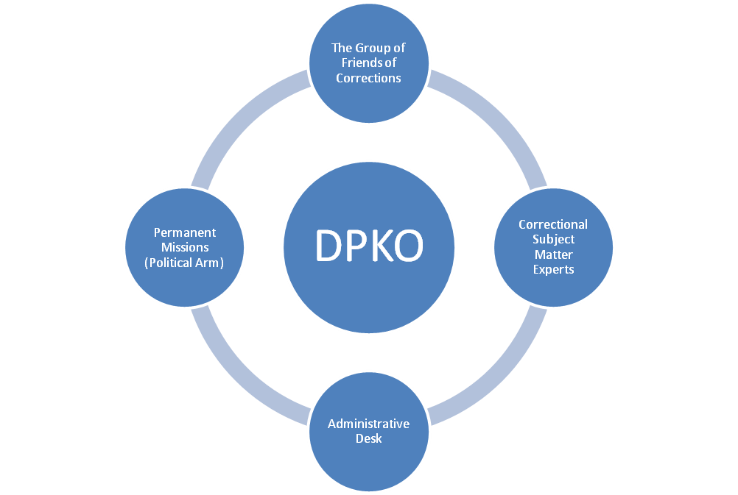

**Role of the Group of Friends of Corrections in Peace Operations**

The Role of the Group of Friends of Corrections in Peace Operations is to provide expert advice, guidance and support on corrections issues, including by:

- Providing political support to the United Nations legislative bodies for the appropriate consideration of corrections issues in United Nations peace operations, ensuring that corrections issues are adequately reflected in Security Council resolutions and that mission budgets include the necessary staffing, equipment and funding for corrections support programmes.

* Addressing critical needs in peace operations settings, by contributing high calibre corrections personnel to be deployed as experts on mission, training of such staff and financial support to critical programmatic activities to strengthen corrections sectors.
* Assisting United Nations peace operations by providing technical expertise for specific projects.
* Providing expert advice and technical assistance to the implementation of corrections mandates, developing policy, guidance and training materials and establishing and strengthening linkages with UN and external partners, when requested by DPKO.

- Supporting the DPKO/UNDP Global Focal Point for police, justice and corrections in post-conflict and crisis situations.

- Providing support to future United Nations conferences on corrections in peace operations settings.

Member States

All Member States, through the Permanent Missions, who have an interest and/or that are engaged in various corrections activities in post-conflict environments are invited to join the Group. While the primary role of the Permanent Missions is to provide advocacy for corrections initiatives in peace operations, PMs are also the primary point of liaison with DPKO on the deployment of corrections officers as well as all Group of Friends activities.

Member States also include national corrections services who provide expert advice, guidance and support on correctional issues, including corrections components of peace operations. Approximately 44 Member States are involved in the Group of Friends of Corrections in Peace Operations.

Correctional Subject Matter Experts (SMEs)

The Group is also supported by Correctional Subject Matter Experts (SMEs). Interested United Nations entities, non-governmental and civil society organizations, training institutes, advocacy groups and national development agencies are invited and encouraged to join the SMEs. The SMEs currently consist of entities such as African Correctional Services Association, Center for International Peace Operations, Euro Prison, International Committee of the Red Cross, International Corrections and Prisons Association, Penal Reform International, and Southern Africa Development Community.

**Functions**

Chair[1]

One Member State will provide administrative functions for the Group. This function should rotate every two years, while respecting geographical diversity to ensure inclusion of varying perspectives and practices. A Member State will be selected by a Quorum of at least three Group members, including the current Chair. The selected incoming Member State to serve as Chair should shadow the current incumbent to ensure conservation of institutional knowledge and facilitate a smooth transition.

The Chair will prepare and lead the Group’s annual meetings, in close collaboration with the actively engaged members. It will be the focal point for all communications and the distribution of information within the Group. It will prepare, in close collaboration with CLJAS, and participate in all Group meetings. It will be the focal point for all communications with DPKO and other United Nations entities. Examples of administrative duties include:

* The coordination of teleconferences and meetings;
* Consolidation of Group activities identified by the Group into a Group work plan;
* Drafting and disseminating updates and invitations regarding Group activities to the whole Group;
* Facilitate and update the website of the Group of Friends of Corrections in Peace Operations, etc.

**Meetings and Activities of the Group of Friends of Corrections in Peace Operations**

The Chair will convene a Group of Friends meeting at least once per year and as required throughout the year. The Group of Friends Chair will prepare and lead these meetings, in conjunction with CLJAS. All Group Members are invited to attend the meetings and the Chair will ensure a Group invitation is issued for each meeting. Those who attend the meetings will be invited to provide input into the current Group agenda. Should Group Members not be able to attend the meetings, they will be invited to send their comments and the Chair will ensure that these remarks are tabled at the meeting.

Any entity interested in corrections activities and in participating in the Group of Friends of Corrections in Peace Operations is able to join the Group.

1. Only Member States, represented by their Permanent Missions, with support of national SMEs are eligible to become the Chair.